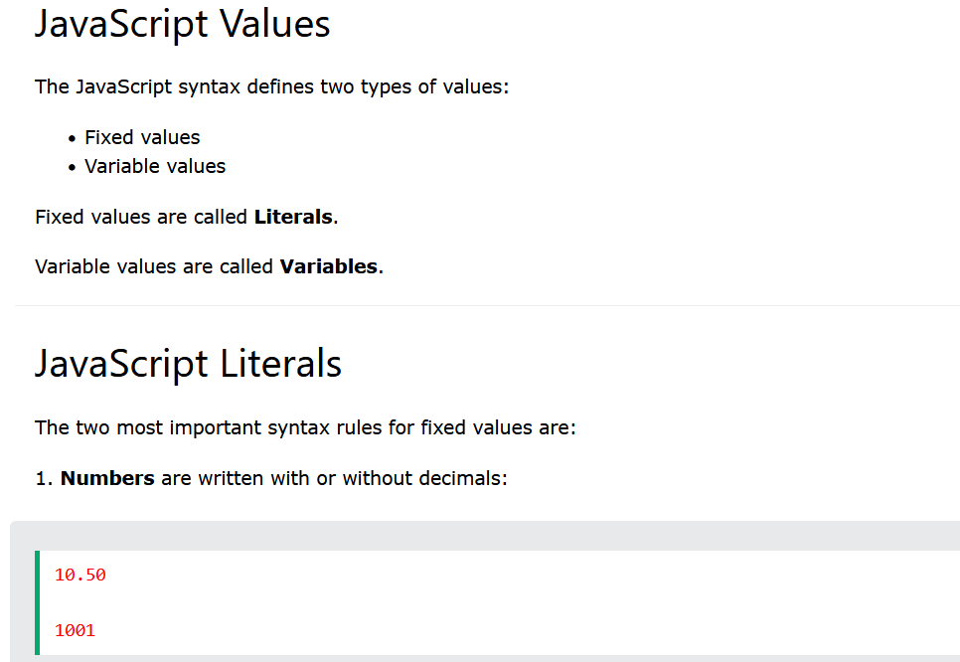

**like there are**

**Number literals**

**Strings literals**

**Literals values are always faster and more efficient**

**So try using them, instead of Objects**

